Post Shaders 3D
by Leo Traub

Interdisciplinary Project
Lehrstuhl Architekturinformatik
TUM

Structure

- Description
- Implementation
  - Post Processing
    - Kernel Filter
    - Canny Edges
    - Halftone Shading
    - Normalmap
    - Camera Depth
    - Ambient Occlusion
  - Mesh Materials
    - Other
    - Wireframe
  - Screen Mask
- Testing
  - Demo Scene
  - Combinations
  - Virtual Reality
- Evaluation

1. Description

The goal of my interdisciplinary project (IDP) was to visualize the geometry of buildings using 3D shaders and postprocessing techniques. In architectural visualization it is important to highlight the edges of the 3D geometry, so that the shape can be seen clearly. The realtime rendering engine that was used is Unity3D. In a future project the post processing shaders might be translated to OpenGL, so that they can be integrated with the CDP.
2. Implementation

Most of the shaders, implemented in my project, are post porcessing shaders. This means, that they are applied after the 3D view of the virtual camera has already been rendered into a texture, which is then modified by the post processing effect. Some of these shaders only make use of the color channel, while others are using additional textures provided by the camera. These are the depth texture and the depth normals texture, which are very useful as we can extract geometric informations from them.
For the desired wireframe effect, it was also necessary to implement a 3D shader for meshes, which has to be set to every mesh separately and is therefore harder to apply to an entire scene. It is also very interesting to think about, what can be achieved, if you combine post processing with certain materials on meshes, which will see in --- xxx ---
Another way to highlight certain parts of a building is, to only render that part with a special effect, while the rest is rendered without any effect. Therefore a mask is drawn on the entire screen before the shaders are calculated, which selectively applies the effects.

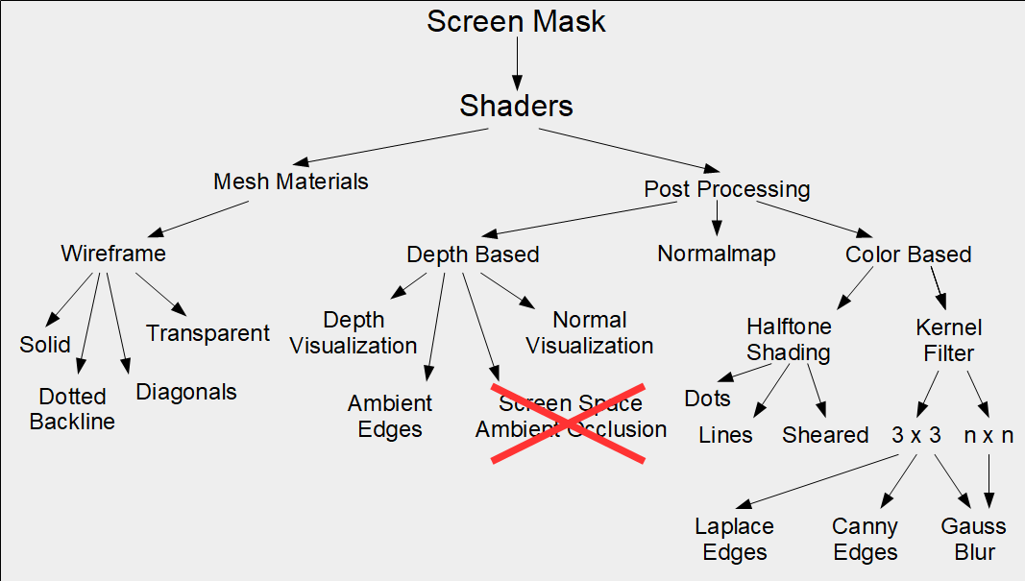

2.1. Post Processing

Post Processing refers to any kind of image effects, that can be applied to an image after rendering. For the project I have only investigated effects, that are useful to visualize buildings in the context of architecture.
In Unity you write the effect as a shader, so that the computations are performed on the GPU, which is more efficient. Many effects are using pixel distances on the screen in theory, but in a Unity shader, you are working with UV coordinates of the screen rect, so many of the shaders need to be used with two values, in order to remap the UV coordinates to pixel distances: The Aspect Ratio, which is 1.78 for 16:9 and the distance between two pixels in UV space.
2.1.1 Kernel Filter

One of the most common ways to manipulate an image, is applying a filter kernel to the image. A filter kernel is a NxN matrix of numbers, often 3x3. Beginning with the bottom left pixel, each pixel of the resulting image is calclulated using the color values of the source image. The pixel that has to be calculated is treated as the center pixel in a way, that each value of the filter kernel is multiplied by the color value of the pixel with the same offset to the center pixel like in the matrix.
The kernel filter is then moved all across the source image to calculate the result.

In theory this sounds rather mathematical but if you look at the example of a simple box blur filter:

To blur the image, every pixel of the result is composed of the surrounding pixels. The value is calculated by simply summing up the surrounding color values (each multiplied by 1), and later dividing the result by 9, in order to normalize the result again.

Using this approach, several rather basic effects can be implemented only by setting up the matrix with the right values. Because of this reason the concept is so powerful. To get a smoother blur effect, you can use a gaussian filter kernel. If you scale the dimensions of the matrix to for example 5x5, then the blur effect does use an even bigger area around a pixel and therefore looks better:

In our case we are using an edge detection filter known as the Laplace filter, which can be implemented as a 3x3 or 5x5 matrix:

In Unity3D we can not assign an arbitrary matrix to a shader, but for a 3x3 matrix, we can simply assign three vectors to a shader, that are then interpreted as a matrix. For a 5x5 or even larger matrix, it was necessary to get tricky. I came up with a way, where you can assign a kernel texture to the shader, that is then interpreted as a matrix. Each pixel value of the kernel texture is a greyscale representation of a number, so the values are between zero and one. The greyscale value of 0.5 is then interpreted as a matrix value of zero and you have to set a multiplier to the entire matrix to reach the desired values of your filter.

Setup for 5x5 Laplace Shader

The minimum import size of a texture in Unity is 32x32, and if you try to import smaller textures (for example for a 5x5 kernel), the sampling does not work correctly. Therefore you should scale an image up to 32x32, after you have setup the pixels for the matrix.

Also you have to manually set the size of the matrix, so that the shader knows, where to sample the matrix values from the texture. You have to be careful with this value, as it exponentially increases the number of texture samples, that have to be performed by the GPU.

As a result the 3x3 edge detection is very sensitive to thin edges and also amplifies noise, while the 5x5 edge filter can also find thick edges and weighs the amplitude by the strength of an edge.
Also the mathematical distribution for Gauss Blur is a continious function, that can be baked into a smoothed texture. This way you can use the same texture independently from the matrix size, that you want to blur with.

2.1.2 Canny Edges

The Canny Edge Detection algorithm is a very powerful way to visualize edges, as it selectively only uses the strongest edges and reduces them to a thickness of one pixel. It makes use of two filter kernels called the Sobel-Operators: One for horizontal edges and one for vertical.
Horizontal Sobel Operator Setup in the 3x3 Kernel Shader

From these two textures the direction of an edge can be estimated at any point on the screen. If you have the direction of an edge, you can perform an action called the Non-Maximum Suppression, which eliminates any pixel on the edge, that does not have the maximum value. This action gives every edge the same thickness.
To give the outcome an even more consistent look, a Hysteresis Treshold operation is performed at the end of the algorithm. That way any edge value beneath the treshold is set to zero, while any value above the treshold is set to one.

In the end you have very sharp and clear edges, which can be combined with other shaders or rendered on top of them very well. Also the shader can be calibrated so sensitive, that it even finds the edges of shadows, which can also give the result a unique look.

2.1.3 Halftone Shading

Halftone Shading is a more artistic way to display a scene. The main reason for implementing this shader in an architectural context was to make a 3D model look like it has been drawn by hand. In the end an algorithm can never replace a good old hand drawing, but there are still some advantages.

The simplest approach of Halftone Shading is the Dotted Halftone Shading. For this approach you slice the screen into small regions of for example 10x10 pixels, and for each of the reasons you calculate the average greyscale value. The you draw a circle inside this region of the screen, with a radius that depends on the greyscale value.

Circles are easy to calculate mathematically, but if you want to use other shapes for the shading, you quickly need the possibility to dynamically assign textures to the shader, in order to experiment and find out, what looks best.
The chosen texture defines a treshold and is tiled accross the screen. For every pixel of the source image the algorithm evaluates wether the greyscale value of the screen is above or below the greyscale value of the tiled texture. This way a pixel of the result can either be black or white in theory, but for my approach I tried out two different approaches: One where actual tresholds are used and one where the treshold defines a soft border , so that the shading does not look so noisy, but smoother.
Treshold Halftone Shading

Dynamic Halftone Shader with smooth borders

The outcomes already look pretty nice on single frames, but as soon as motion comes into play, the effect looks weird. One major drawdack is, that you can see the tiles of the texture all across the screen, which is even more obvious, when you move the camera, and the white pixels stay in the same place.

The last aspect of the shader was optimized for the visualization of 3D geometry: The shearing factor. The idea is simple: The texture is sheared (meaning the UV corrdinates are manipulated) depending on the screen space normals. This way you can not only hide the tiling effect, but you can also see the different normal directions of walls better and therefore the edge between those walls.

2.1.4 Normalmap

The Normalmap Shader was some kind of lucky coincidence. Actually I wanted to implement a shader, that computes the normals from the depthmap of the current view. At that point I did not know, that you can simply access the screen space normals without having to compute them. In the end I implemented a shader, that generates a bumpmap of the current view at runtime. A bumpmap can also be called a normalmap, but it is in fact not a map of the normals.
Normalmap generated from view

This shader is not very useful as a post processing effect, but could be really useful for a mesh shader, where you directly want to compute the normalmap from the texture, to enhance your lighting computations.

2.1.5 Camera Depth

In Unity you can directly access the depth map from any camera, that is currently rendering. The depth map stores informations about how far an object is away from the camera, for each pixel. The values are very precise floats ranging from zero to one, but when directly mapped to a greyscale image, the data is compressed to 256 different depth levels. You can also map the values to a color gradient, like for example a rainbow texture. This way you don't lose so much information.
Another dataset you can directly access in Unity, are the depth normals. These are simply the normals of any surface in view space. As you typically get a very colorful and bright image from the depth normals, it might be useful to map them to greyscale values.
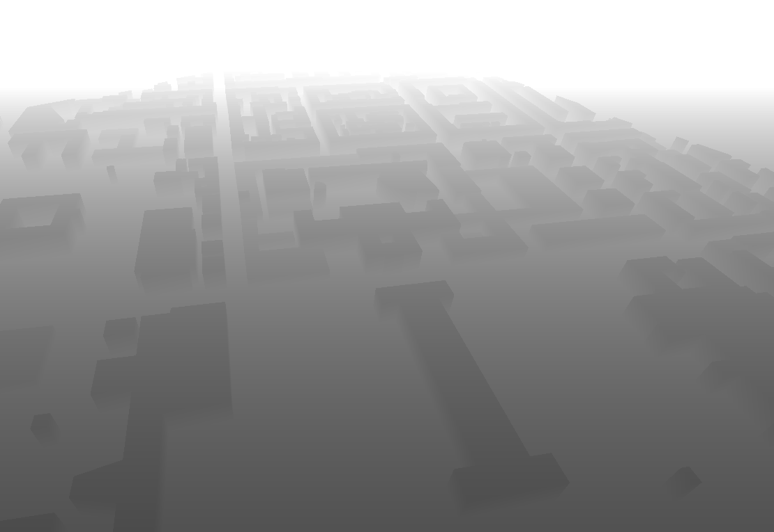
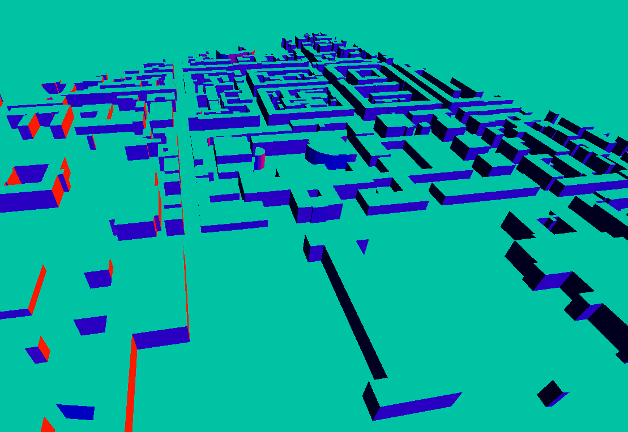
Depth greyscale (1), Depth gradient (2), Depth Normals raw (3), Depth Normals greyscale (4)

Both textures, the depth map and the depth normal map, are not very good to visualize architecture, if you use them raw, but they can both be used very well in combination with other effects. Especially the depth normals are providing a lot of informations about the geometry and edges, which we want to visualize in architectural renderings.
2.1.6 Ambient Occlusion

Ambient Occlusion is a shadow like effect, that occurs, when two surfaces are close to each other, because light can not shine so bright into narrow spaces. A variant of the effect called Screen Space Ambient Occlusion (SSAO) can be implemented using the depth data and the screen space normals and is often used to simply make scenes in video games more realistic, as it is very efficient compared to other effects.
Unity already provides a SSAO effect as a part of their post processing stack, which is sadly not customizable at all, as you don't really get any insights on how the effect is exactly implemented. When trying to implement the effect on my own, I ran into a lot of problems, which simply made it impossible to get the desired results. The problems were related to transformations from linear eye space to screen space or to world space. There was simply no setup, that could satisfy the constraints for SSAO.
In the end I worked out some effect, that looks a bit like SSAO and also visualizes edges, but not in a very realistic way. For real Ambient Occlusion the shadows should only be drawn between surfaces, that are forming a concave structure and not on convex edges. In my approach, the algorithm does not distinguish between those edges and simply adds shadows to any kind of edge in the scene. I called it Ambient Edges.

If you want real Ambient Occlusion in Unity, you should probably just use the provided effect, as it is not worth going through all the work, that is need to get similar results.

2.2. Mesh Materials

Post processing is not the only way to highlight the geometry of a building. In fact you could think of a a lot of different approaches to interesting shaders. As the focus of my IDP was to work with post processing effects, I did not dive very deep into these topics, but there was one effect, that is definitely needed in architecture and that can simply not be achieved with post processing. The wireframe representation of a 3D mesh is very useful, when it comes to visualizing buildings.
Also there are some post processing shaders, that work better with the right materials on the meshes, before applying the effects. Therefore it was also possible to come up with shader solutions.

2.2.1 Default Shading

It was necessary to write a very simple default shader for meshes, as the Unity default shader is creating some weird artifacts, of you look at a surface from a close angle. As a result of error propagation, these artifacts were causing a lot of noise for the Laplace or Canny Edge Detection. Although it is necessary to calculate the lighting on a mesh for a lot of post processing shaders, it can be rather bad, if you have advanced effects like specularities on a mesh. Therefore I implemented the most simple mesh shader you could think off, so that it works well with all the different post processing techniques.

2.2.2 Wireframe

Wireframe shading is a well known approach to showing the geometry of a 3D Mesh. The simple idea is, that the edges of the mesh are drawn with another color than the faces. This way you directly see the triangles, that any three dimensional shape is composed of. You can also make the faces transparent, so that you can see the edges on the back of the mesh and you can give those edges a different color or make them dotted in order to clearly keep them apart from the front edges.
In the end, you get a very invormative representation of the geometry, that you want to visualize. Of course this effect is not used for realistic renderings, but for precise sketches or renderings you want to work with.
One problem of the effect is, that it shows every edge between triangles, and not only the edges between quads. The drawback is, that you often have too many edges, that make it more difficult to interpret the image. Luckily it is possible to switch off the diagonal edges of quads, if the mesh is stored in the right way and the polygons are defined as quads.
In the end I came up with a wireframe shader, that combines all the described options.

xxx missing images xxx

2.3. Screen Mask

In the context of the CDP you often want to highlight one building in between a lot of other buildings. Therefore it is very useful to only apply the desired post processing effect to that single building.
While it is very simple to exchange the mesh material of a single object, it is rather diffcult to only render a certain screen area with a post processing shader, as post processing typically just uses the entire screen texture, that is rendered by a camera and does not distinguish between objects in the scene.
In my approach I am using a setup, where you have two cameras, that are rendering the scene: One camera simply renders everything without any effects while the other camera only renders the desired object, in order to a apply a shader to it. The rest of the second rendertexture is transparent, so that you can simply place it on top of the default view. It somehow works like a mask, that is applied to the entire screen.
You can control the mask, by changing the layer of an object in Unity. The second camera only renders that layer. The rendertextures are then layered in the UI using rawimage components. There is a little drawback to this approach, because you have to set the size of the rendertextures to your screen size before you can use it (1366x768 at the moment).
You could probably also write a post processing shader that directly combines the textures, without having to use UI components, but that was not so simple to do in a dynamically exchangeable way.

xxx missing images xxx

3. Testing

For testing the shaders, I have built a dynamic demo scene, where you can switch between all of the different shaders and have a lot of different environmental and scene options.
Also some shaders turned out to work even better in combination with other shaders, in order to highlight certain aspects of 3D meshes better.
In Virtual Reality xxx missing xxx

3.1. Demo Scene

The Demo scene consists of four different menus: One to choose the current environment, one for the desired shader, one with scene options and for some shaders, you are also provided with shader specific options. You can navigate and change your view by using keyboard and mouse input.

Demo Scene (City view tih treshold halftone shading)

For the environments, you can choose between different kinds of buildings with different degress of detail. The default scene is a city view with the coarse geometry of the district around the TUM building in Munich. This view was generated from open street data and represents, what the view in the CDP also usually looks like. Then there is a scene with a detailed 3D model of a building and one scene with a default tree by Unity. These two scenes should demonstrate how the shaders behave in rather realistic environments. And there are also some scenes with very undetailed buildings for testing cases, where for example one building is round and another one has a hole (for wireframe testing). The last scene simply contains a sphere which can be used to test different halftone shading options.

For the Shaders you can choose between all the options described in 2.

For the scene options, you can switch off things like the ground, shadows, the sky, or the textures of the models inside the scene. Some shaders simply work best with the right setup here, as the shadows are sometimes generating misleading informations or the sky gives a better contrast if it is simply black. There is also an option to set the camera view to orthographic and the option to use a post processing mask like described in 2.3. To do so, simply click on an object, while the option is enabled. That changes the layer of the selected object.

There are shader options for three different shaders at the moment: The wireframe shader, the dynamic halftone shader and the treshold halftone shader. Of course there are a lot of different options for the other shaders too, but most of these options don't have to be changed at runtime. Something like the texture or the raster size of a halftone shader is just very practical to be used at runtime, where you directly see the impact of different options. Also some values need to be calibrated in order to get the perfect screenshot.

3.2. Combinations

Simply Combine...

